**CSC 5750 – Principles of Web Technology**

**Homework 5 – Part 2 of 2 – Caleb Latimer**

**18 of 25 points – Due November 21, 6pm**

**Late deadline is November 23, 11:59pm, but 3 points off**

**a)** Save this document with your name and the homework number somewhere in the file name.

**b)** Type/paste your answers into the document.

**c)** Gather the following files into a ZIP file:

● This document

● Cashier page (.HTML)

● Summary page (.PHP)

● Any other optional files specific to your implementation

**d)** Submit the ZIP file to the Blackboard item where you downloaded this document.

You've been hired again by the local restaurant that you created a web site for in Homeworks 1, 3, and 4. Enhance that web site per the following:

**Cashier page**

Modify the **Cashier** page per the following:

● Place files **JSONentrees.txt** and **JSONdrinks.txt** in your web application stack web folder (for example, folder **C:\Program Files (x86)\Ampps\www** on Windows AMPPS).

● Instead of reading data from declared array **entrees** to build the entrees combo box, use an AJAX call to read file **JSONentrees.txt** from your local server and parse it into array **entrees**. Name the XMLHttpRequest object **xhttp1**.

● Instead of reading data from declared array **drinks** to build the drinks combo box, use an AJAX call to read file **JSONdrinks.txt** from your local server and parse it into array **drinks**. Name the XMLHttpRequest object **xhttp2**.

● Both AJAX calls may be placed in function **loadComboBoxes**. To give time for the AJAX calls to complete, there should be a pause of about two seconds before attempting to set the combo boxes with selections from a sale (done in function **loadData** here). This is shown here and the Homework 4 key:

<body class="cashier" onload="loadComboBoxes();setTimeout(loadData, 2000);" onunload="saveData()">

● Add button **Summary** and function **showSummary** that:

1) Loop through the sales array to calculate the following overall sale totals (shown with green arrows below):

→ Total (before tip)

→ Tip total

→ Total with tip

You need to rebuild the totals for each sale. For example:

for (var i = 0; i < sales.length; i++)

{

// Get inputs

row = sales[i][1];

entreeCost = entrees[row][1];

row = sales[i][2];

drinkCost = drinks[row][1];

tipPercent = parseInt(sales[i][3]);

…

}

2) Build a query string with four values:

→ Sale count

→ Total (before tip)

→ Tip total

→ Total with tip

3) Open PHP page **Summary** (described below) using a URL including the query string.

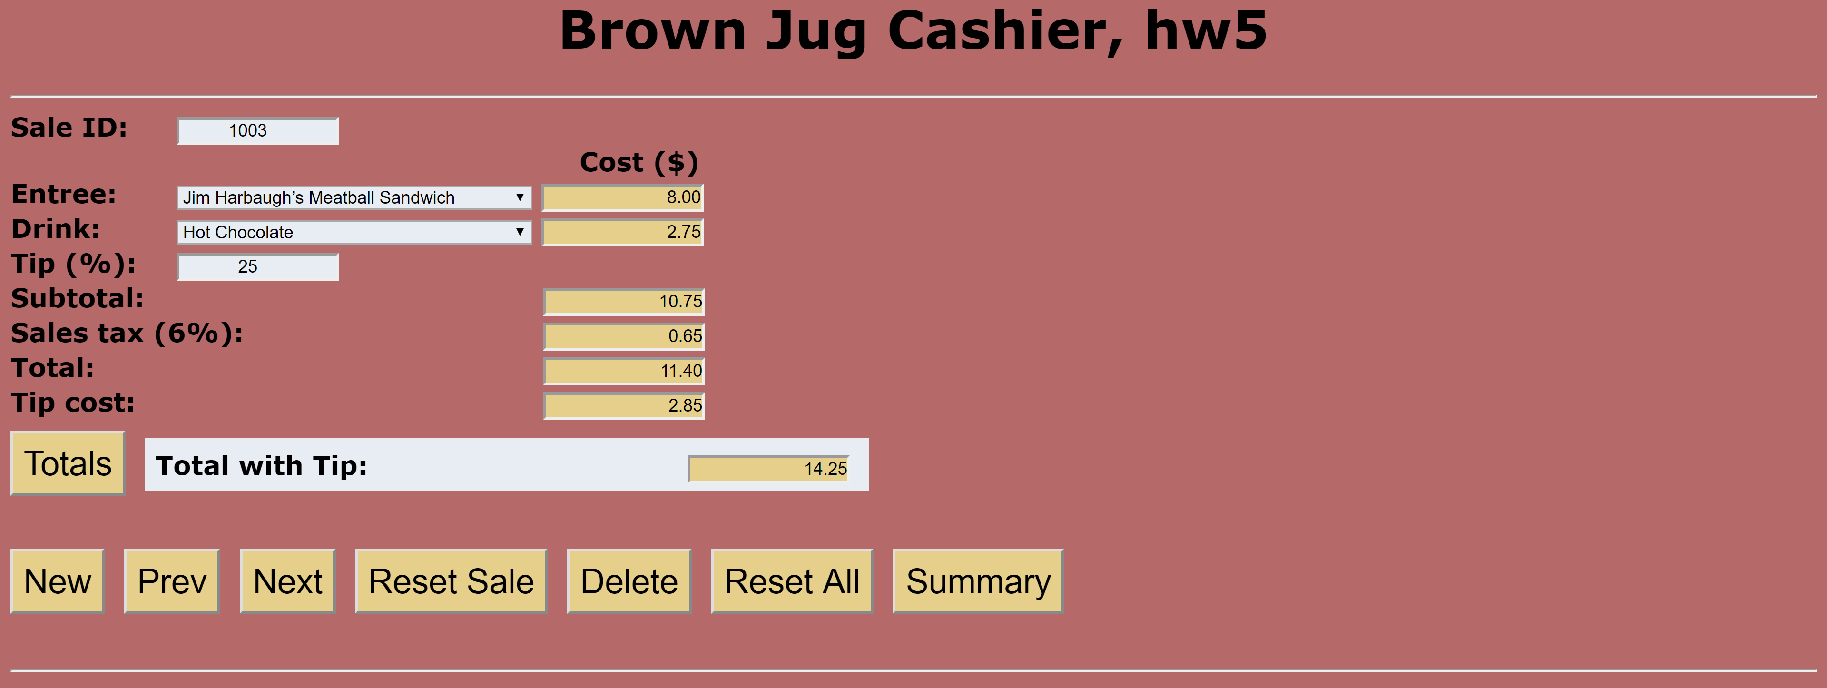

**Summary page**

Add PHP page **Summary** with the following label-text box pairs:

● Sales

● Total (before tip)

● Tip total

● Total with tip

Use PHP global variable **$_GET** to retrieve the values from the query string and embed them within the HTML.

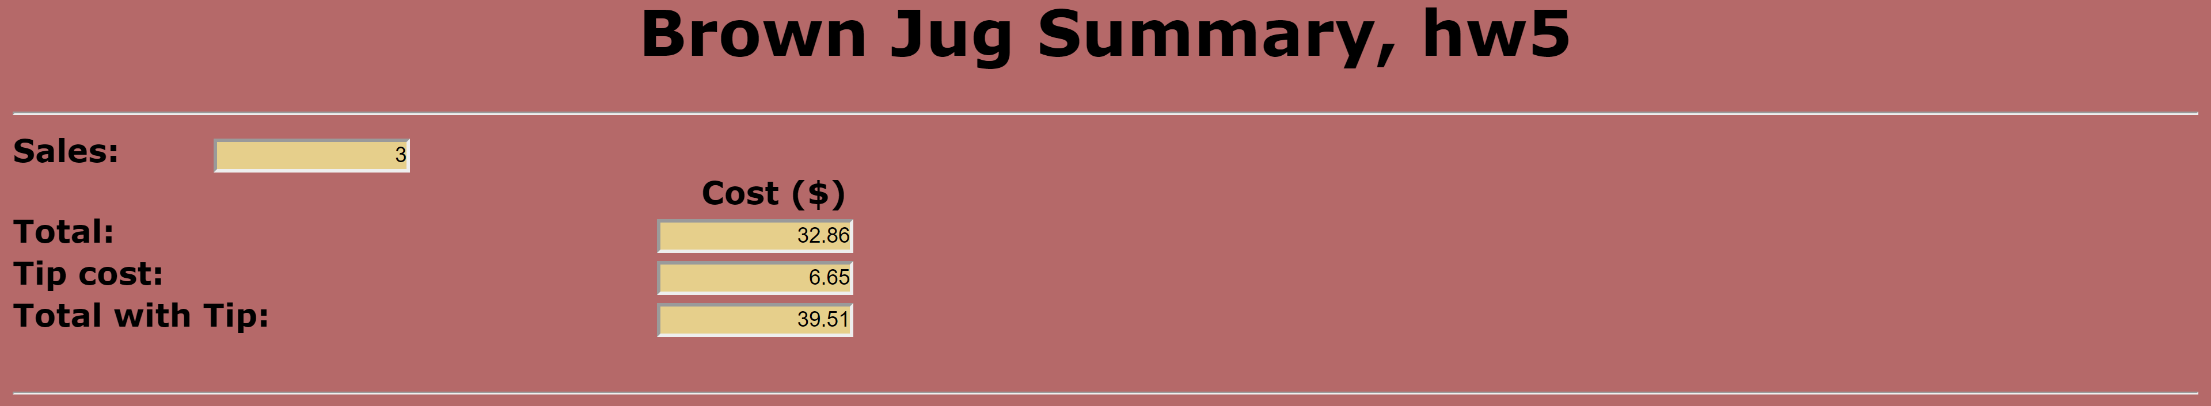

**Screenshots**

Include the following screenshots in this document:

● Cashier page – at least three sales.

● Summary page

**Cashier page**

*[your Cashier page HTML code here]\**

**If possible, format your code like this:**

**Font “Courier New”**

**Font size “9”**

**Bold**

*[your Cashier page screenshots here]\*\**

**Summary page**

*[your Summary page PHP code here]\**

**If possible, format your code like this:**

**Font “Courier New”**

**Font size “9”**

**Bold**

*[your Summary page screenshots here]\*\**

* **Copying-and-pasting web page code to a Word document**

1) From the HTML editor window, press **CTRL-A** and press **CTRL-C**.

2) From within the Word document, press **CTRL-V**.

** **Copying-and-pasting application output to a Word document**

1) From the web page, maximize the browser window.

2) From the browser window, press **ALT-PrintScreen**.

3) From within the Word document, press **CTRL-V**.